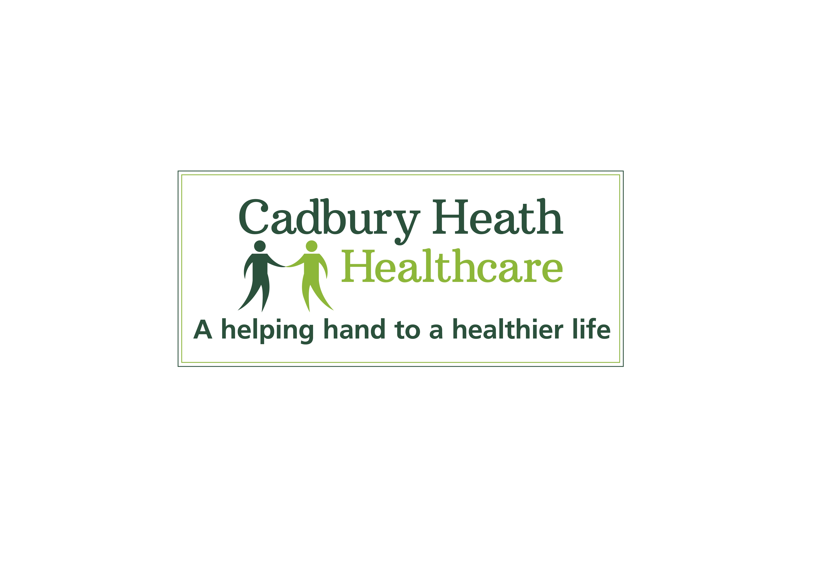
Cadbury Heath Healthcare

Cadbury Heath Healthcare
Salaried GP required to work 4 – 8 sessions per week

Would you like to join an outstanding practice? We are a progressive and forward thinking practice and have been rated as Outstanding by CQC.
We have a rare opportunity for a salaried GP to join us, these opportunities arise infrequently due to the stability and low turnover of our GP team.
We are a friendly and patient centred practice and we have 4 Clinical Partners a Managing Partner and 6 Associate GP’s, with a list size of over 11,700 patients, which is growing rapidly.

Our Practice also benefits from the following:
- Multidisciplinary team working – with a Senior Clinical Pharmacist, Paramedic and Nurse prescribers
- Training Practice with 2 GP trainers
- Core teaching practice for University of Bristol medical students
- Strong nursing and administrative teams
- Purpose built health centre with on-site community services e.g. District Nurses, Health Visitors, Midwives and Community Matron
- Excellent MDT links with weekly primary healthcare team meetings
- Regular in house clinical meetings and education
- Emis Web
- Specialist nurse to deliver diabetic care
- In house joint injections, dermatoscope and excellent palliative care
- Substance misuse service
- Full sexual health and contraceptive services
- Very close links with Juice our community team
- Patient walking group
- Regular well-being weeks for staff.
If you are interested in this excellent opportunity and would like to join our friendly, supportive and close knit team we would very much like to hear from you and welcome you for an informal visit.

For further information please contact: Kath Horne Managing Partner, email - KatherineHorne@nhs.net or telephone – 0117 9805724. Closing date – 16th November 2020

