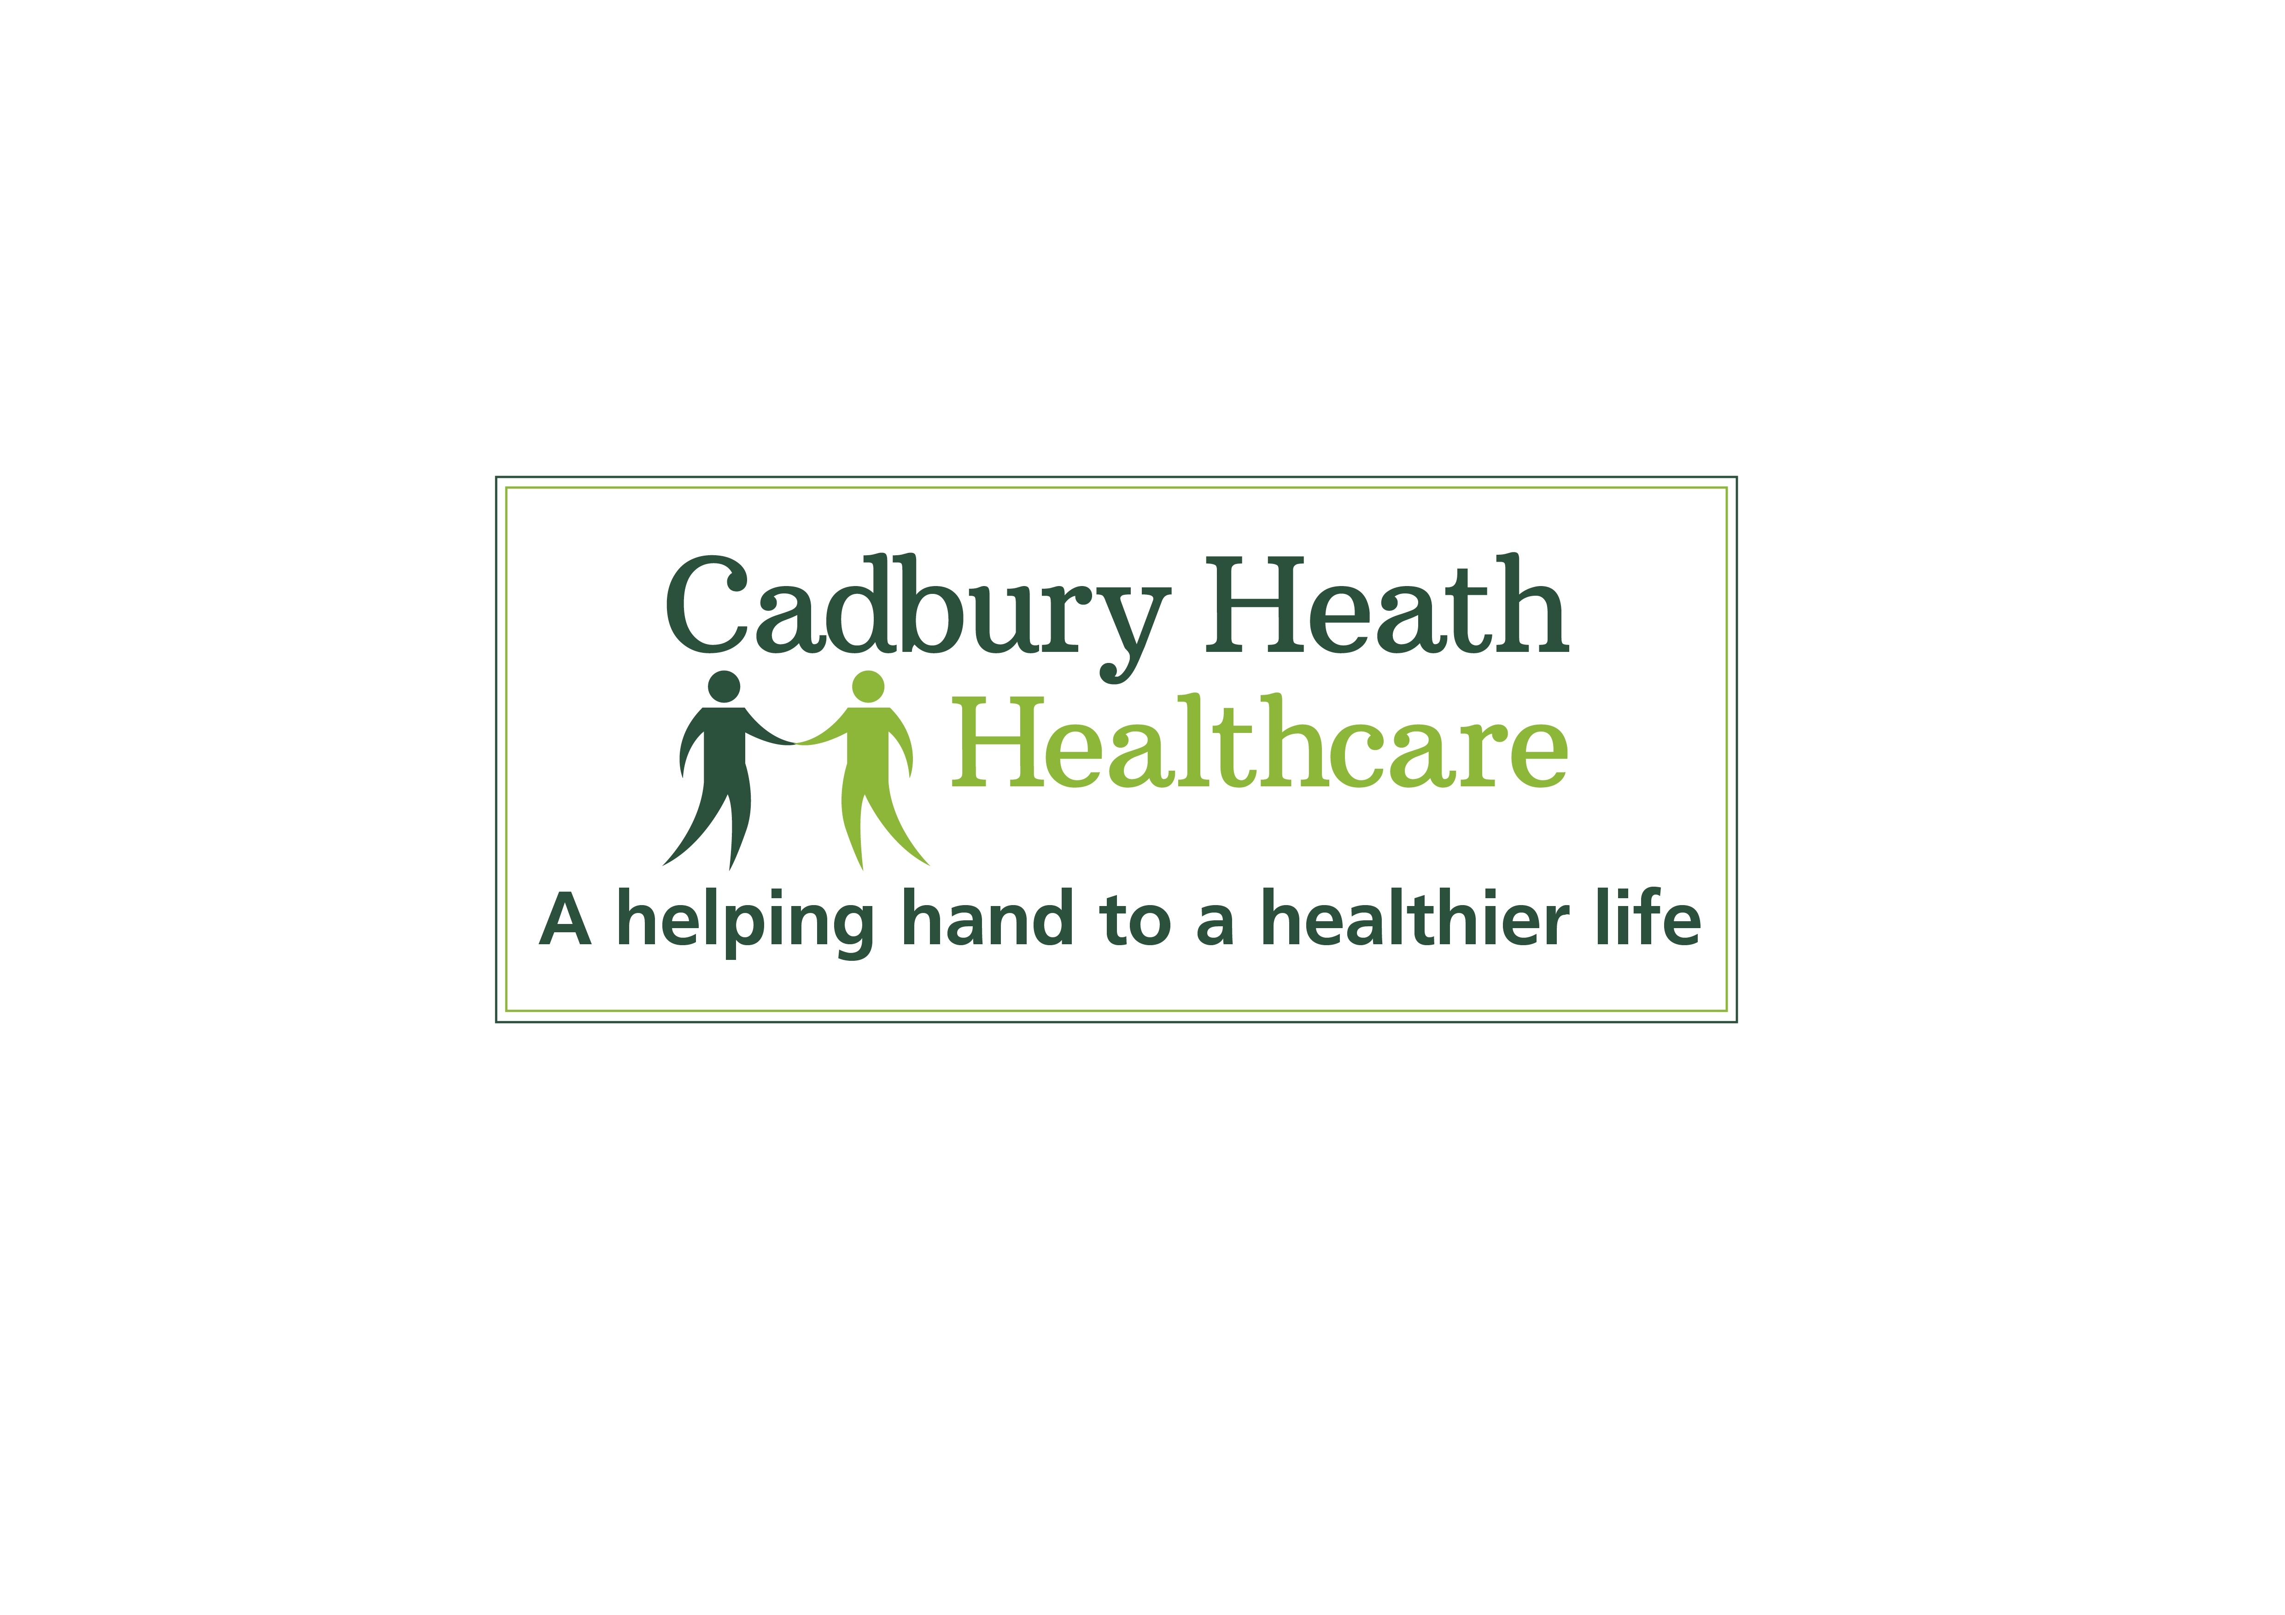
Cadbury Heath Healthcare

Cadbury Heath Healthcare Plan recovery after COVID-19

Background

The COVID-19 pandemic represents a major national and global challenge ever since the first cases were reported in China at the end of last year. By May 2020, there are still many unanswered questions about the novel Coronavirus SARS-2, and strategies have recently been aimed at limiting the human-to-human transmission of the virus, as well as protecting the vulnerable population against severe complications and even death.

The disease has had a major impact not only economically, but also on the health and mental wellbeing of the population.

Cadbury Heath healthcare was one of the first to act by changing the consultation model of General Practice by operating on the principles of:

- Limiting footfall in the practice by utilising our telephone first model and increasing the use of video consultations
- Postponing non-essential /non urgent work
- Practicing safe practices at work including the enforcement of social distancing, as well as several other measures which have proved invaluable.
It is clear that there is a burden of work slowly building up that is non COVID related, and the impact of delaying this for longer than needed will have a significant impact on the long-term health and wellbeing of our population.

This plan aims to spell out the process of how Cadbury Heath healthcare can make the transition from the status quo to what we can define as business as usual.

A new normal

What is absolutely clear, and one of the thinnest of silver linings from the current crisis is that our practice will have a new ‘normal’ in the longer term. The lessons we have learnt around the utilisation of technology, reducing the need for face to face consults and a new relationship with patients, presents an opportunity for the longer-term future for our practice. We should also horizon scan and learn from the experiences of others.

We must also be flexible and responsive to the changing threat of this pandemic. With so many unknowns around subsequent waves of infection, long term immunity, vaccine development and successful treatments, as well as the possibility of the disease becoming endemic, our response must be able to change within hours whilst never compromising patient care.

The national response

On 10 May 2020, the Prime Minister of the United Kingdom and Northern Ireland announced the Governments recovery strategy. This involved the launch of an alert system which charts both the national and local picture of COVID-19, and the appropriate response to the pandemic.

- Level 1 - COVID-19 is not known to be present in the UK
- Level 2 - COVID-19 is present in the UK, but the number of cases and transmission is low
- Level 3 - A COVID-19 epidemic is in general circulation
- Level 4 - A COVID-19 epidemic is in general circulation; transmission is high or rising exponentially
- Level 5 - As level 4 and there is a material risk of healthcare services being overwhelmed
At the time of the announcement, the country was told that we were currently on level 4. Although there are potential hazards in this approach, it gives us the basis of a plan to ‘unlock’ the practice.

Our practice response

We have decided to use the national alert system as a barometer as to what level we are at in the practice. Although we will use the national guidance as to the current threat level, given the time lag and limitations of the alert system, in particular geographical variation in disease activity, we will always underwrite this with our own assessment as a practice leadership team. This will be guided by the precautionary principle and will identify our Agreed Alert State

In this document we will outline the processes we will follow to make sure that we are keeping our patients and staff safe, whilst still maintaining a local and responsive GP service for the people in our community.

To avoid any ambiguity, we will have the current Agreed Alert State clearly displayed in the practice and on our practice intranet, so everybody knows the level we are currently operating at.
It is the Practice Manager and partners responsibility to keep this maintained and updated, and to make sure all staff are appraised of the implications of the changing alert level.

To underpin this, our broad approach to communications in the practice should include:
- Regular updates on Clarity TeamNet
- Distribution of messages through staff briefings in addition to regular meetings followed up with email
- regular practice meetings
- one care bulletins forwarded to staff members as well as frequent email alerts

Test, trace and isolate

National contact tracing requires isolation of ‘contacts’ of Covid-19 positive individuals for 14 days. A ‘contact’ is someone who spends more than 15 minutes with a Covid-19 individual, at less than 2 metres separation, without wearing appropriate PPE. If our practice guidelines are followed appropriately by the team, they should NEVER be considered a contact of a patient or another team member, when attending the surgery. If there is a breakdown of our practice guidelines such as PPE failure or emergency care of a patient, then this should be notified to the partners or Practice Manager immediately the opportunity arises, and this should be well in advance of any contact tracing process.

Things to continue until further notice

- Regular messages from IPC (SN Amy Gibson)
- Screen/Perspex at Reception Desk
- Floor spacers alerting people to remain 2 metres apart and direction of traffic
around the building
- SITREPs with the Management Team
- regular social distancing audits

Communications to patients

- Website to be updated by the Practice Manager, or a member of the business support team setting clear messages and expectations
- Engagement with the PPG to remain remote at present
- Social media to be updated as required to ensure patients know the changing level of service provision
- Targeted text messages for patients to buy equipment if they can afford e.g. BP machines

We will demonstrate over the coming weeks and months, that our service provision to patients is both responsive and safe. The pace of the pandemic in the United Kingdom is uncertain and we are unsure about the size of any subsequent waves of infection. By using the steps in this plan, we will be able to step up and step down our response quickly.

Staff

Where possible all the team should practice social distancing. Line managers can assist staff, where possible with remaining 2 metres apart at work. High levels of hygiene and handwashing are to be maintained throughout. All staff to follow infection control measures please (e.g. bare below the elbows please, no name badge lanyards, watches etc). Staff will use the entrance appropriate to their role for their work session.

Appropriate levels of personal protective equipment will be available. Staff can wear their own PPE if requested subject to approval by the IPC Lead. Staff groups are encouraged to stagger lunch and coffee breaks in designated area / own rooms. Food must be individually wrapped but ideally is not brought in at all.

The Practice Manager and partners will conduct Staff Risk Assessments, making adjustments to limit patient contact where appropriate and mutually agreed. This assessment will take into account age, sex, ethnicity and underlying health conditions or current pregnancy.

Practice Meetings should be taking place using MS Teams /socially distanced meetings face-to-face. Paperwork will be sent electronically wherever possible.

Remote working can be considered for staff wherever possible and appropriate. If a team member scores 3 on risk or more on risk assessment but does not meet shielding criteria, then enhanced social distancing is recommended with homeworking advised until Agreed Alert Level 2 (Moderate) is met.
The building

For the duration of the Covid-19 emergency (Alert Levels 5 to 2 inclusive) the building will be utilised as 3 different zones Red, Amber, Green. The high-risk area of RED ZONE will remain constant through all of these alert levels. The rooms designated to AMBER and GREEN may flex with demand and alert level.

[RED ZONE] (High risk area)
This area is reserved for seeing patients who have a raised possibility of having active Covid-19 by virtue of their symptoms (fever, cough, and severe flu like illness, loss of sense of taste or smell). It is accessed from its own entrance and is an area kept separate from the rest of the building. Staff seeing patients wear the highest level PPE. Administrative staff do not normally enter this area. (Currently treatment room D accessed via the side entrance past the conservatory – contingency for expansion to treatment room C)

- Symptomatic patients will be assessed via Video Call prior to the appointment.
- This area is self-contained and does not communicate with the rest of the building except through the clinician door.
- The responsibility of the PPE shall be updated daily by the lead nurse. Further information is available on our staff intranet with videos on how to use and dispose of this appropriately.
- Patients will enter the building via the side entrance (conservatory) when instructed to do so by the assessing clinician, they will call the CHHC emergency telephone number so that the reception staff can alert the GP of their arrival. This can be texted to the patient following triage.
- Instructions will be given to patient on arrival to the surgery and until they depart.
- They will not be able to use the practice toilet whilst in the building without clinician consent (will be reminded to go before they attend the practice).
- This area may be subject to a cleaning cycle (even if not in use throughout the day).
- Patients should be seen on arrival into the area.
- After each consultation, the attending clinician is to wipe down surfaces and handles as per CHHC cleaning schedule.
- The clinician MUST not leave the Red zone whilst wearing PPE.
- Clinicians must be permitted a timeout after seeing a high-risk patient before resuming their clinical responsibilities
[AMBER ZONE] (Background risk area)
This is an area of the building for seeing patients who have a level of risk of having Covid-19 similar to the background risk of the general population. Clinical staff seeing patients wear intermediate level (2*) PPE. Administrative staff wear low level (1*) PPE.

- This area represents the Clinical rooms (GP rooms and nursing rooms Except Rx room D and A)
- This area will be for essential face to face appointments already agreed that need to take place for patients who only have the background risk of being infectious for Corona virus
- All patients will routinely be questioned regarding Covid-19 symptoms prior to attending and this will be recorded in the medical record.
- Patients will enter the building via main entrance and let into the building via main entrance doors when the clinician is ready.
- Where possible patients should be asked to wait in their cars, if this is not possible and if it is raining then patients should be asked if they wish to wait outside or in the waiting area. If the patient chooses to wait inside then they must wear a face covering and be 2 metres apart. Chairs will be wiped down after every use.
- Floor spacers will guide patients about the correct distance of 2 metres.

- Upon arrival to the main entrance, there is an alcohol hand gel dispenser and instruction poster of how to wash their hands.

[GREEN ZONE] (Vulnerable patient area)
The primary purpose of this area is to afford added protection for patients who may be particularly vulnerable to the effects of Covid-19 and who may be taking a heightened self-care approach in the community. Clinical staff seeing patients wear intermediate level (2*) PPE but change aprons, gloves between patients. Administrative staff wear low level (1*) PPE. Vulnerable patients are designated shielding patients, pregnant patients and babies up to eight weeks of age.
The Green Zone will be defined in response to demand and reverts to Amber Zone after scheduled use for vulnerable patients. We have designated treatment room A to remain a permanent Green zone throughout the day.

- This zone is all clinical rooms except for treatment room D, once these rooms are used for patients, they will remain Amber for the remainder of the day.
- This area is used primarily for the first appointment of the day.
- All patients [will be screened prior to and upon arrival for viral symptoms – by enquiring about Covid symptoms and screening for fever symptoms.

- Mother and baby:
- Treatment room A is a designated room that has all equipment for babies – weighing machine etc
- Only clinicians are to be using this room
- There are Webcams in every room for video consults
- Stocked daily with handwashing equipment and other infection control measures.
- Spot inspections by lead nurse to check infection control procedures.
- This area shall be for the exclusive use of baby checks immunisations and high-risk/previously shielded patients

Ventilation

Frequent air exchange reduces virus transmission risk - windows should be open whenever possible and [air conditioning should remain off] for the duration of the emergency.

Physical distancing

Physical distancing will be encouraged throughout the emergency and where group seating is required such as in waiting and meeting rooms, 2 meters separation of seating will be in place or the seats to be used will be clearly identified.

- Waiting rooms use should be minimised and the 2 metres rule applied
- Alcohol hand gel is freely available, and its use required on entry and exit

Toilets

- Patients can use main toilets in the waiting room toilets but are advised not to do so if possible.
- [Red Zone] patients may only use the toilet (disabled toilet) with their clinician’s agreement and deep cleaning before further use is required if Covid-19 is suspected after the consultation.

Personal Protection

We aim to build and maintain [a month’s stock] of PPE ready for any subsequent wave and this should meet WHO or UK criteria whichever is the more stringent and should have regard to emerging data on transmission, to give our returning team reassurance. Our approach, based on the precautionary principle*, is dependent on the availability of suitable PPE.

Room cleaning

- Suspected Covid-19 deep clean
- Background risk surfaces and handles ‘Clenil’ wiped, medical equipment replaced or ‘Clenil’ wiped as appropriate
- Cleaning rota throughout the building

PPE levels

*3 (Highest protection) for patients with raised possibility of Covid-19, seen in [Red Zone].
- Aprons
- FFP3 mask for aerosol generating procedures (AGPs) otherwise Surgical IIR fluid resistant masks
- Visors
- Scrubs, shoe coverings and head coverings discretionary but available for those that want them

*2 (Intermediate protection) for face to face consultations for background risk or shielding patients.
- Aprons
- Single gloves changed for each patient
- Surgical IIR fluid resistant masks (sessional)
- Simple re-useable eye protection (wrap around glasses) (sessional)
- Scrubs, shoe coverings and head coverings discretionary but available for those that want them

*1 (Basic protection) for clinicians and admin team not examining patients.
- Maintain social distancing
- Bare below the elbows and hygiene+++
- Surgical IIR mask if risk of not maintaining 2 metres physical separation
- Perspex barriers at reception or desks where workstations are less than 2 metres apart

For patients:
- Maintain distancing i.e. at reception desk and in waiting rooms
- Face coverings mandatory for all aged 11 years or over attending the surgery. We will maintain a stock of surgical masks or fabric masks to be handed to those not wearing. We will not refuse immediate health care to any patient declining to wear a face covering. This is in line with GMC guidance.
- Hand hygiene (soap or alcohol) will be provided

Communication (consultation) types

accuRx
- Asynchronous communication
- Text consultations are used for providing advice and gathering information from patients.
- They are predominantly used as a single instance of communication- a statement or a single question and answer.

Email eConsultations message
Asynchronous communication
- eConsultation enables patients to request a response or advice in a written. Unless a patient specifically requests ‘email’ response a phone or video call will be made during the crisis (Levels 2-5). Email responses may be used to collect further information e.g. skin images, provide information or signpost the patient to alternative or additional resources.
Telephone
- Synchronous communication (dialogue)
- Telephone consultations comprise the majority of consultations allowing for free exchange of information between patient and consulter

Video via accuRx
- Synchronous communication (dialogue)
- Video communications can enhance remote consultations enabling better engagement with some patients, identify visual queues and enable a degree of remote examination. It may be particularly useful for distressed patients, and those with MSK problems.
- Video consultations will be offered to a majority of patients who are being considered for F2F review in Red Zone.
Face to Face
- Synchronous communication (dialogue)
- This will be used where physical examination is required, when there are more complex communication requirements or where there is diagnostic uncertainty. Due to increased risk of transmission of Coronavirus from F2F appointment the threshold for F2F appointments will change dependent on clinical presentation and on the Agreed Alert Level (the latter is a proxy for the background prevalence of Coronavirus infection), in order to reduce risk of transmission of infection between patients and between patients and staff and vice versa.
At each stage we will review the types of appointments available and the number of
Nurse and GP Clinic pre-bookable appointments available and how best to deliver these whether remote or practice based.

LEVEL 4/5 – Severe

- Transmission is either high or rising exponentially.
- Staff will be at greater risk from infection in the community and from increased contact with symptomatic members of the household.
- Consequence for patients is that there will be significant numbers of patients presenting with new onset flu like symptoms most will be dealt with by 111.
- Practice will have more demand on Red Zone and likely have depleted workforce from consequence of social isolation/quarantine. There may be increased demand for home visiting of Covid-19 patients and for care of patients with non-Covid illness co-presenting with Covid-19 infection.
- All patient requests for appointments will be managed through a telephone first approach with a detailed history collected remotely through a combination of phone, video,
- Where possible patients should be encouraged to use online facilities (e.g. eConsultation to keep the telephone lines free for those that cannot avail of this.
- The appointments will be administered on Zone Specific Lists
- The use of a home visit is a last resort and wherever possible the patient should be seen in the surgery.
- Assess possible COVID19 patients by telephone and/or video consultation and, if necessary, see in Red Zone Rx Room D following double triage. Clinicians wear *3 PPE. Patients wear surgical mask and gloves.
- Patient appointments will be limited to one person at a time in each area (and a carer/parent if appropriate), this will be facilitated by spacing appointments out throughout the day with sufficient time for consult / clean, fitting PPE and writing notes.
  - Red Zone patients [i.e. wait in car until collected] and patient to wear mask
- The door is closed and the Clinician will meet the patient at the Main Entrance
- The clinician will be ready waiting for the patient at the allotted time; the patients should not be waiting for a clinician to arrive.
- If a patient is running late, then the next patient will have to wait until they have left, until they enter the building.
- Any patient who attends the surgery that is subsequently believed to have COVID, please see Pandemic Plan on Clarity TeamNet or contact NURSE LEAD or PRACTICE MANAGER for the escalation procedure.
- Patients and Clinicians will be reminded that appointments must stick to time and to be aware of the implications of overrunning and the option to continue a conversation on the telephone later can be offered.

LEVEL 3 – Substantial

- Virus is in general circulation.
- Fewer patients presenting with Covdid-19 or illness with concurrent Covid-19 and demand on Blue wing will fall.
- Action: Shorten Red Zone clinics
- More patients getting used to Covid-19 risks will start wanting treatment for non-urgent conditions or more serious conditions that fear of Covid-19 has kept them from presenting with.
- Action: Increase nursing chronic disease management provision in Amber Zone. GPs reduce threshold for face to face. No longer require case discussion for patients being brought down for their own personal review. Joint discussion remains in place for remote working GPs when booking F2F.

LEVEL 2 – Moderate

- Number of cases and transmission is low.
- There are few cases and test and trace are in effect. Flu like symptoms when presenting to still treated in [Red Zone] but use is ad-hoc.
- Action: The dedicated [Red Zone] sessional team is stood down. Risk 0 clinicians are identified from day to day who will attend Blue Wing to see Covid-19 higher risk patients. They will have additional time allocated for donning and doffing. Showering is available prior to return to non Covid-19 zones.
- (Winter may bring about an up-take in the incidence of flu like illness and require reinstatement of dedicated [Red Zone] team’s in-spite of lower Covid-19 incidence.)
- Community social distancing has been relaxed and all staff can return to working from the surgery premises for at least part of their working week.

LEVEL 1 – LOW RISK

- This level represents no new cases of COVID-19 in the United Kingdom and the risk to General Practice being negligible. This represents the new normal for [Practice] in its service delivery.
- Actions: [Red Zone, Amber Zone, Green Zone] are stood down with immediate effect.
- [Purple Zone] remains as a patient free area but is reduced to [named area/ location within the practice].
- All Covid-19 temporary structures are to be removed.
- Social distancing: Physical distancing reverts to normal social spacing, work-station separation for staff and waiting room seating returns to normal.
- Social interactions in the practice returns to normal.
- Face coverings may be worn if desired but are no longer mandatory.
- Outstanding staff social gatherings to be rescheduled and resumed
- A practice [meeting/ Away Day] will be planned as soon as is possible to reflect, heal and look at the lessons learned through the COVID-19 crisis.
Our principles:

- Ensuring everyone can access services on an equal footing and promoting targeted access for specific groups based on their needs to address inequalities in access to health services and the outcomes achieved.
- Healthcare starts with supported self-care; from disease prevention to illness management, patients, carers and their families are supported to share responsibility for their healthcare at every point of contact with the care system
- The value that continuity of care brings in increased patient satisfaction, improved outcomes and cost savings, is considered in all care pathways and all services we develop.
- Care is provided as close to home as possible by the right person, at the right time and the right place
- Face to face contact is used where it offers additional value to the patient so that remote working is maximised to reduce stress on our environment and demand on our physical facilities
- Accepting there is risk and supporting clinicians and patients to work in an environment that is able to manage this risk
- Only those patients who need ward-based care are admitted to hospital and all other patients are managed and supported in an appropriate community environment
- We work collaboratively with our entire care community, including patient representatives, to develop and construct the care pathways and services that patients need, and that the system can deliver.
- Deliver value, through informed decision making on the services we provide based on our population need and the resources available

Advice to patients
Cadbury Heath healthcare, as part of its ‘Covid Secure’ assessment requires all patients to wear face coverings when attending the surgery, as it may be difficult to maintain effective social distancing separation within the surgery and pharmacy premises. In order to protect other patients and staff at the surgery, we are asking that all patients and visitors to the surgery wear a face covering. If you attend the surgery for a non-urgent problem, you may not be able to be seen at the time of your appointment unless you are wearing an appropriate face covering. If your problem is considered urgent and you do not have your own face covering, you may be required to wear a cloth face covering supplied by the surgery before being seen.
We ask for the patient and only one essential carer or family member to attend the surgery wherever possible. If the carer or the single family member accompanies the patient into the surgery or the pharmacy premises, then we ask that both of you wear face coverings.
The exception to this would be if wearing a face covering might cause significant distress to the patient, or if they are a child under the age of 11 years.

