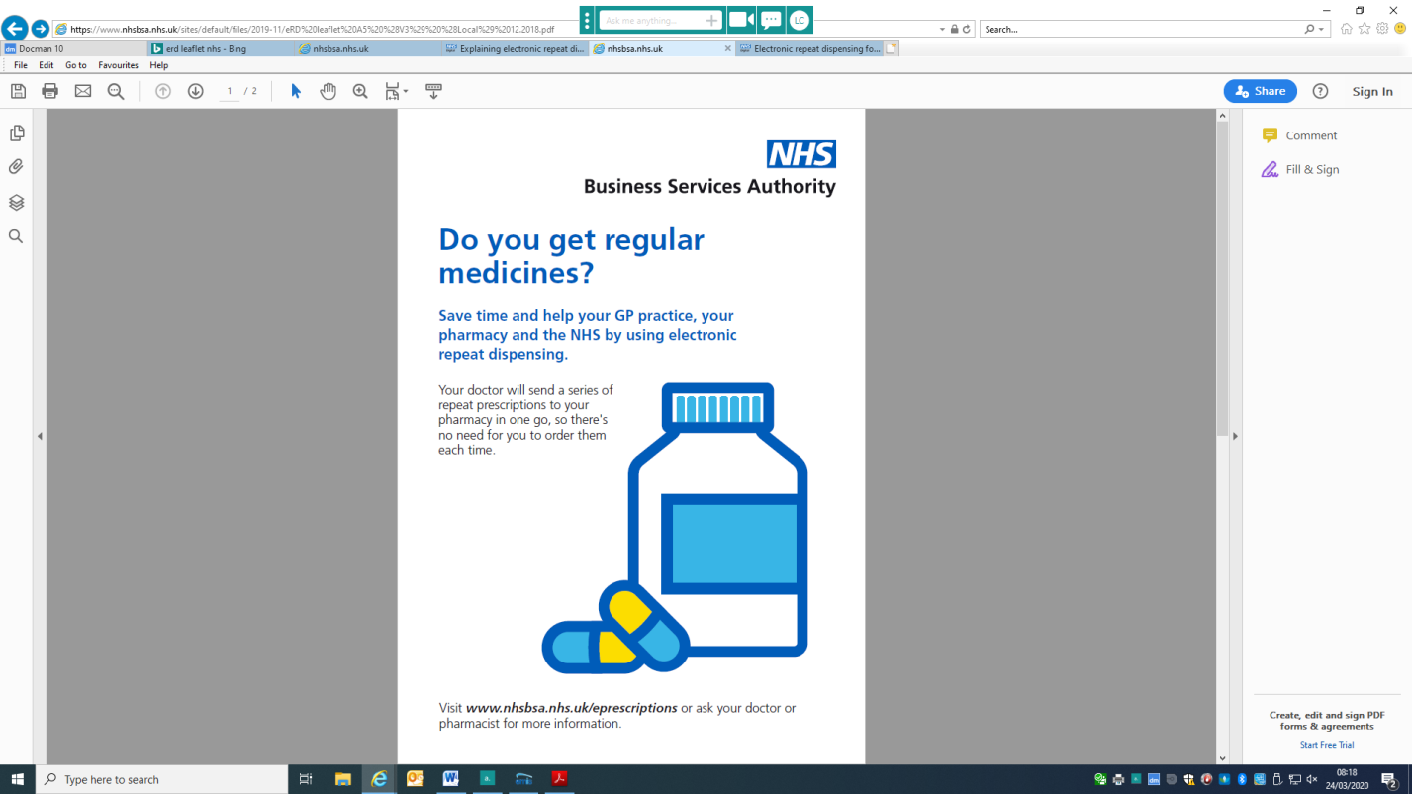****

**Electronic prescriptions – A new way to get your regular prescriptions**

If you or someone you care for uses the same medicines regularly, you may be able to benefit from electronic repeat prescriptions. This means you won't have to re-order or collect your repeat prescriptions from your GP practice every time you need more medicine.

Get your prescriptions electronically and save time and money for the NHS.

**Electronic prescriptions service (EPS)**

EPS is replacing the need for most paper prescriptions, working towards a paper free NHS. You can send your prescription electronically from your doctor’s surgery to your chosen pharmacy.

**Electronic repeat dispensing (eRD) service**

This service could help you if you regularly get a prescription for the same medication.

Your doctor will give your pharmacy permission to dispense a series of prescriptions for you.

This means you do not need to arrange repeat prescriptions, you can just go to your pharmacy to collect your medication when you need it.

**Step 1**

If your prescriber thinks that you could use electronic repeat prescriptions for your regular medicines, they will ask you for permission to share information about your treatment with your pharmacist. This will help your pharmacist to give your prescriber feedback about your treatment and provide you with useful advice. If you have already nominated a pharmacy for electronic prescriptions then this permission has previously been given.

Your GP or prescriber will then authorise a number of electronic repeat prescriptions. This will be based on your circumstances and clinical need. These electronic repeat prescriptions will then be supplied to you by your pharmacy at regular intervals.

**Step 2**

Collect your first electronic repeat prescription from your pharmacy.

**Step 3**

When you need more medicines, go back to your pharmacy. Before dispensing the next issue of your prescription, your pharmacy will ask:

* have you seen any health professionals (GP, nurse or hospital doctor), since your last repeat prescription was supplied?
* have you recently started taking any new medicines - either on prescription or that you have bought over the counter?
* have you been having any problems with your medication or experiencing any side effects?
* are there any items on your repeat prescription that you don't need this month?

If you don't need all of the medicines on your prescription, let the pharmacy staff know, so that they only supply the medicines you need. This will help to reduce waste and save the NHS money.

You should ask your pharmacy how they would like to know when you need more medications, some may ask you to call them a few days before you need your prescription so they can make sure they have the items for you.

**Step 4**

When your pharmacy supplies your final electronic repeat prescription in the series that your GP has authorised, they will advise you to contact your GP practice.

Your doctor or practice nurse may want to see you to review your medication before they will authorise more electronic repeat prescriptions.

**Medication Reviews**

At Cadbury Heath we will contact you about any annual reviews you may need – this may be for blood tests or a review with the nurse, pharmacist or doctor. Where possible we will line up your reviews and your prescriptions to reduce the number of visits to the surgery

**How to sign up**

In these difficult times we have decided to switch all appropriate patients to electronic repeat dispensing – this is following guidance form NHS England. If you have questions about the service or wish to withdraw please book a call with your pharmacist or GP to discuss.

*Information taken from NHS Business Services Authority, NHS Digital*

