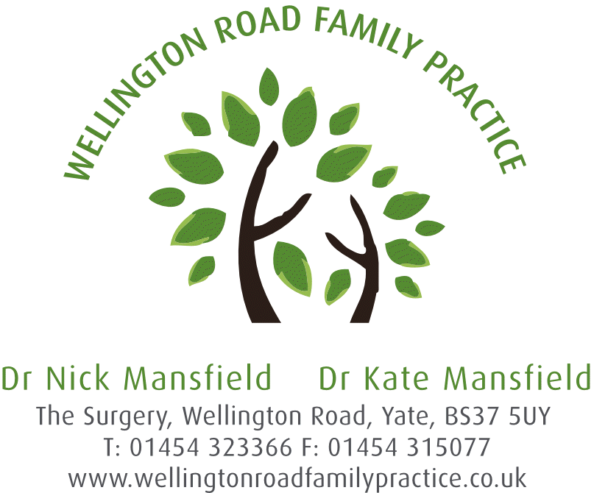
Wellington Road Family Practice and Cadbury Heath Health Care

From the Partners of Wellington Road Family Practice and Cadbury Heath Health Care
The Partners of Wellington Road Family Practice and Cadbury Heath Health Care would like to take this opportunity to brief all of their respective patients about a new development in the leadership and ownership of the two Practices. Following a lengthy period of discussion and deliberation the Partners of both organisations have decided to bring together the two respective Partnerships into one, so that a single Partnership will encompass both Wellington Road and Cadbury Heath. This development provides a long term and sustainable basis for both Practices to continue to provide high quality patient centred healthcare to their local communities.
This decision has been under consideration for about a year, as both sets of Partners sought opportunities to create a leadership team with the experience, expertise and critical mass required to lead the two organisations into the future. The Partners of both Practices each hold a similar patient centred ethos and this formed the original basis for discussions.
As you may be aware Dr Kate Mansfield, Partner at Wellington Road Family Practice, is seriously ill. As a consequence these plans became pressing, in order to provide leadership resilience and to ensure that a long term plan was developed.
It is very important to point out that whilst the leadership of Wellington Road and Cadbury Heath will come together, into one single partnership entity, consisting of all of the Partners from both organisations, both Practices will continue to operate as they do now. There is no intention whatsoever to close either site, in fact this initiative is intended to protect both locations into the future.
We have produced the following list of Questions and Answers (Q&A) in order to provide as much information as we can at this stage.

Questions and Answers
- Will I be expected to attend at the other practice location to see a doctor or receive treatment?
- No patient will be asked to attend at the other site to see a doctor or receive treatment. Both Practice locations will continue to provide access to clinicians and doctors.
- Will our ‘open surgery’, also known as ‘sit and wait’ change (Wellington Road Family Practice)?
- We do not intend to change this approach in the short term, however over the coming months we will review the operating model at Wellington Road Family Practice on the basis of patient care, effectiveness, efficiency and affordability. We will communicate and consult with patients prior to embarking on any change to the current approach to GP appointments.
- Will all the Partners work at one location?
- As part of the creation of the new expanded Partnership covering both locations we will establish the optimal geographic deployment of our Partner Team. This will ensure that we have sufficient Partner presence and visibility at both locations to ensure they each receive sufficient clinical coverage, leadership and governance.
- Is this a merger of the two Practices?
- This is not a merger of Practices. The Partnership’s that own and lead the Practices are however changing, by bringing both sets of Partners together into a new single Partnership agreement covering both locations. Both locations will continue to deliver high quality patient care to their respective local communities.
- Will anyone at either Practice lose their job as a result of these changes?
- We will not be making anyone redundant as a result of the creation of the new Partnership. We envisage requiring all of the current staff that we have in place to deliver.
- Do we have any choice in this?
- The decision to change the Partnership is a decision by the Partners and for the reasons articulated above the respective Partners of each location have decided to go ahead with this change. This decision is also supported and agreed by the Bristol, North Somerset and South Gloucestershire Clinical Commissioning Group. However we do want to communicate with you and to listen to you about how the change is going to be implemented. We will therefore hold meetings with patients at each location, led by the Partners. This will ensure that you can ask questions, contribute your ideas and make suggestions as to how the two locations can operate better in the future. You will also have the opportunity to tell us if you have any concerns or if you think we have missed anything, so that we can respond accordingly.

- Will the opening hours of the Practices change?
- The hours of opening of both Practices will not change as a result of this change to the Partnership. Clearly opening hours and patient access are important factors which may need to change in future due to changes in how GP Practices will be expected to operate, by the government, NHS England or the CCG, but there are no plans for this at the moment and the Partnership change will not directly lead to such changes.
This patient briefing has been produced on behalf of all of the Partners of Wellington Road Family Practice and Cadbury Heath Health Care.

If you require any further information please do not hesitate to put your questions in an email to either cadburyheath.healthcare@nhs.net﻿ or wellingtonroad@nhs.net we will aim to respond within 2 working days.

